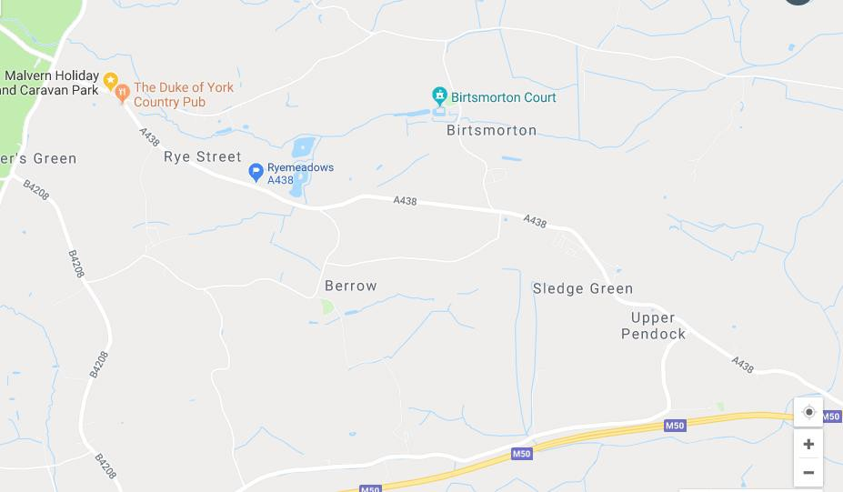

WCRA Championships – Venue at Ryemeadows PWRC, Rye Street, Birtsmorton, Malvern, Worcester WR13 6AT

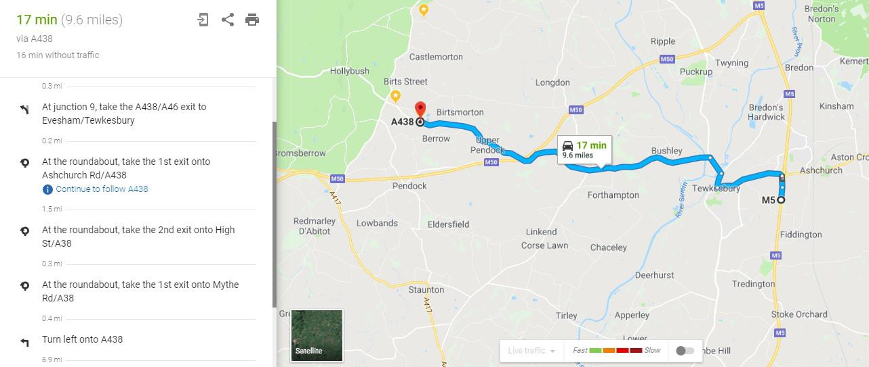

Directions from M5 South, Junction 9.

Track is on the right hand side; you have gone too far if you get to the Duke of York pub on the left hand side.

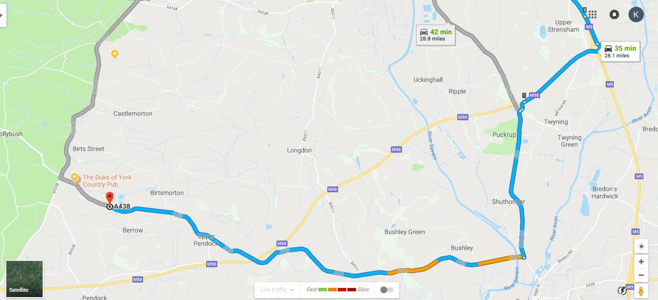

Directions from M5 North, Junction 8

•

•

•

•

•

At Junction 8, exit towards M50/South Wales/Ross

At Strensham Interchange, take the 2nd Exit onto M50 heading to South Wales/Ross. At Junction 1, take the A38 exit to Malvern, continue onto A38 for 9 miles

At the roundabout take the 1st exit and stay on A38 for 2.3 miles

Turn right onto A438 for 7 miles, Ryemeadows track is on the right hand side.

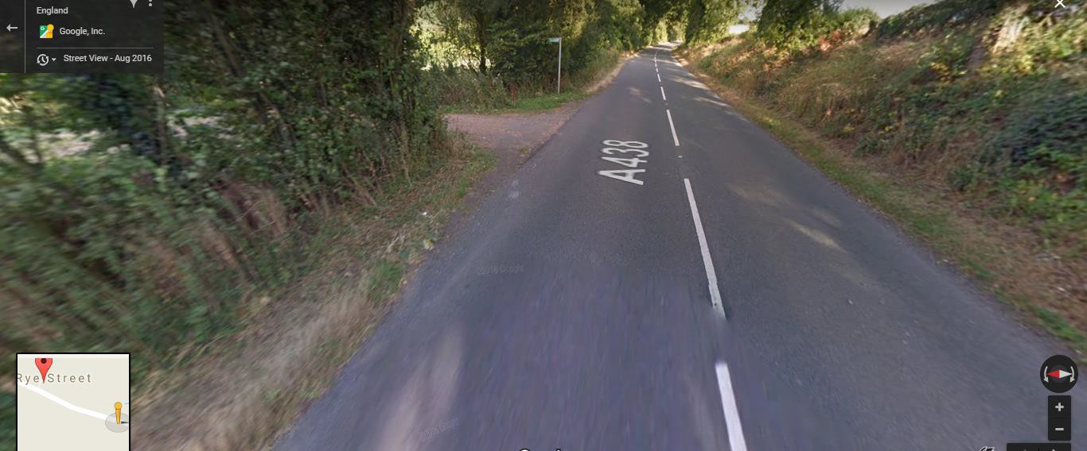

Entrance to the track from the Rye Street direction